Ansible Assignment-1

There should be ansible workstation and host machine. Keep the WAR file ready on workstation. Install java 17, tomcat 10 on host machine. Deploy the WAR file on host machine. Start the tomcat and see the output.
1. Used ansible module adhoc commands
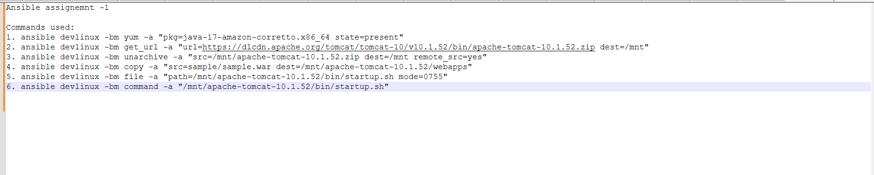

2. Output
